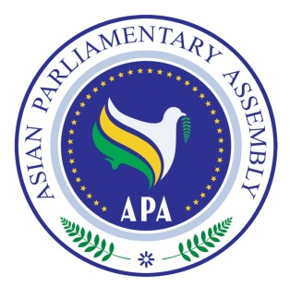

APA Standing Committee Meeting on
Social and Cultural Affairs

12 – 15 February 2019
Bangkok – Kingdom of Thailand

Draft Agenda

1- Adoption of the Agenda
2- Election of the Bureau
3- Opening Remarks by Chairperson
4- Report of APA Secretary General
5- The Meeting of APA Women Parliamentarians
6- Consideration and discussion on new Draft Resolutions:
- Draft Resolution on the Promotion of Quality Child and Youth Development for Sustainable Society in Asia,
- Draft Resolution on Ageing Society in Asia,
- Draft Resolution on Building the Asian Individual
7- Consideration and recommendation of following Draft Resolutions:
- Draft Resolution on Measures to Promote Cultural Diversity and Protect Cultural Heritage in Asia,
- Draft Resolution on Asian Integration through Information and Communication Technology,
- Draft Resolution on Collaboration on Health Equity in Asia,
- Draft Resolution on Protection and Promotion of the Rights of Migrant Workers in Asia,
- Draft Resolution on Asian Parliamentarians Against Corruption
- Draft Resolution on APA Women Parliamentarians,
- Draft Resolution on Promoting Inter- Faith Dialogue and Harmony among World Religions,
- Draft Resolution on Legal and Legislative Cooperation in Combating the Smuggling of Cultural Items in Asia,
- Draft Resolution on Effective Cooperation in Combating Illicit Drug Trafficking in Asia,
- Draft Resolution on Humanitarian Aid to Syria, Iraq, Yemen, and Myanmar on the Verge of the Humanitarian Catastrophe
8- Any other matters.

As of 8 February 2019

